**Guru Teg Bahadur Public Sr .Sec. School Noorpur (Bijnor)**

Holiday Homework (Class-X) Session 2015-16

**Maths**

1. Revise Chapter 1 & 2.
2. Assignment Chapter 1 & 2.
3. Chart
4. Lab Activity 1, 2 & 3.

**Science**

Physics

1. Learn chapter-1
2. Assignment Chapter 1
3. Do experiment No. 5, 6, 7 exercises only
4. Do exercises page no. 38, 39, 40, 41 & 42.

**Chemistry**

1. Learn chapter 1
2. Assignment 1
3. Experiment no. 2 exercise

**Biology**

1. Draw diagram of Human Digestive System.
2. Learn chapter-1
3. Assignment Chapter-1

**fgUnh**

1 + lwjnkl ds okRlY; jl dh dforkvksa ds ckjs esa le>kb;s rFkk lwjnkl dh dkO; d`fr;ksa ds ckjs esa Kku vftZRk dhft,A

2 + nso dfoRr vkSj lS;k ds inks ads lkj fy[kksA

3 + usrkth lqHkk’kpanz cksl dh thouh fyf[k,] ns”k ds izfr muds ;ksxnku dh lkFkZdrk crkb;sA

4 + x`gLFk vkSj laU;klh dks foLrkj ls le>kvksA

5 + ekrk&fiRkk ds okRlY; dks le>kvksA

6 +NqfV~V;ksa esa ftl LFkku ij ?kweus x, gks ml LFkku ds ckjs esa foLrkj ls crk,aaA

7 + vki vius n~okjk [ksys x, [ksy dk fooj.k nhft,] tks lokZf/kd yksdfiz; FkkA

**Art Skill**

1. Landscape
2. Draw the landscape using pencil colour.
3. Draw the landscape use of pen and brush.
4. Creativity:
5. Create X-Ray fountain.

Material: –Plastic bottle, Thermocol ball, scissor, glue, cell tape, fabric colour.

**Computer**

1. Send 10 e-mail to your computer teacher.
2. What is the b/w search engine and web browser? Give 5 examples.
3. Assignment- 1 Network, Types of Network, Need of Network, Benefit of Network
4. Assignment- 2 Internet, Services of Internet, History.

**English**

1. The two boys belonged to a very good family but they understood the gravity of the situation and never hesitated to do any work. Write a short paragraph on ‘Dignity of Labour’ with relevance to the story “The Two Gentlemen of Verona’.
2. Your younger sister is seriously ill but you have your exams so you have not been able to meet her. Write a diary entry expressing your concern for your younger sister. (150 words)
3. Write the character in the story: (a) Mrs. Packletide (b) Mrs. Loona Bimberton
4. Write about two vertices: (a) A.J. Cronin (b) Saki
5. Write about the poets: (a) William Wordsworth (b) Vikram Seth

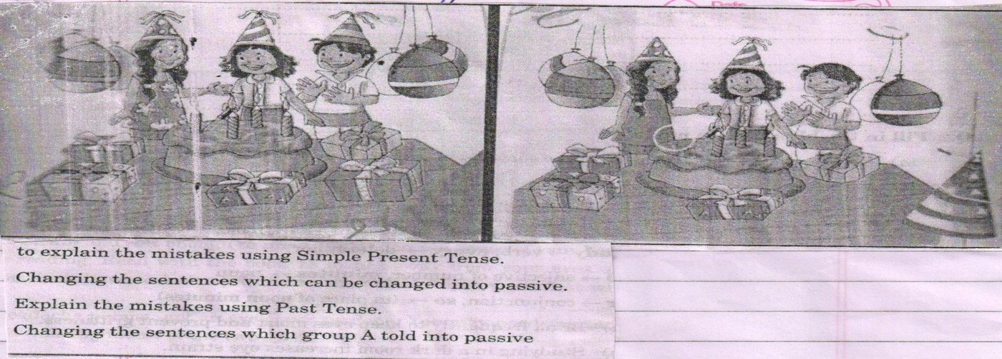

**S.Sc.**

1. Lab Manual: Page 24, 25 & 26

(i) Visit an agricultural form and collect the following information: Paste related pictures also.

(ii) Page 27, 28 & 2- Visit a nearby farm and collect the information as given number.

(iii) History: Lab Manual Page 39.

(iv) Economics: Lab Manual page 85.

2. Prepare a newspaper report to show the destructive impact of colonialism on the livelihood of colonized people.

3. Make a project showing consumption and conservation of resources in your locality.

4. Prepare a assignment on MNREGA. (Cover the aspects-Meaning, year of launching, reasons for launching the scheme, its impact, its limitations)

5. Read any newspaper for one week and make clipping of news related to ongoing conflict or wars. A group of five students could pool their clippings together and do the following:

Classify there conflicts by their location (Your state, India, outside India)

Find out the cause of each of these conflicts, how many of these are related to poorer sharing disputes?

Which of these conflicts could be resolved by working out power sharing arrangements?

**Note:All the students take the holiday homework seriously as 30% weightage of marks for Formative -II Exams shall be taken from Holiday Homework.**

**uksV% lHkh fo|kFkhZ xzh’ekodk”k x`gdk;Z dks xaHkhjrk ls ysa D;ksafd QkWesZfVo&2 ijh{kk esa 30% vad xzh’ekodk”k x`gdk;Z ds gksaxsA**

**For Any query, please contact: 8410127358, 7533838585, 9084221322, 9412394858**

**You can also log in to school id:** [**www.gtbps.in**](http://www.gtbps.in) **to download holiday homework.**

**Best of Luck**